
LOAN INVESTMENT MEMORANDUM
150 E Aurora Street, Waterbury, CT 06708

Transaction Overview:
Castellan Capital will provide a senior loan of $2,240,000 for the acquisition and renovation of the industrial property located at 150 E Aurora St, Waterbury, CT. Reign Funding will provide a $660,000 junior loan subordinate to Castellan’s position. The purchase price of the property is $3,000,000, and the borrower has budgeted $1,700,000 for capital expenditures. Of this amount, $950,000 will be financed by Castellan and Reign once the borrower has spent the initial $750,000. Upon renovation, the borrower plans to lease up the property and refinance it with a permanent loan.

Sponsorship Overview:
- Business background: According to the resume provided to Castellan, Shaya Margareten is the founder & operator of SMHI, a construction firm based in Monsey, New Jersey. Shaya is a real estate investor focused on high-yield, value-add properties and growing his portfolio through strategic acquisitions, renovations, and refinancing. SMHI delivers large-scale renovations and turnkey commercial projects—from industrial warehouses to healthcare facilities. Key holdings include stabilized multifamily buildings and retail strips generating $1.2M + annual NOI.
- Personal financials: According to the personal financial statement submitted to Castellan, Mr. Margareten has a net worth of $3.68MM. This includes approximately $2.80MM of real estate assets.
- Background & credit check results: Castellan engaged Eaglescreen to perform civil and criminal record checks on the borrower. Based on the results, there were no records of bankruptcy, tax liens or pending civil or criminal suits. In addition, online searches did not reveal any derogatory or adverse information about Mr. Margareten. Additionally, the credit report indicated that the sponsor has a strong credit score of +793.

Submarket Overview:
The subject property is located at the southwest corner of East Aurora Street and Gear Street in the Browns Meadows neighbourhood of Waterbury, New Haven County, Connecticut. The immediate area is predominantly industrial, characterized by a concentration of industrial buildings and supporting infrastructure.
Waterbury occupies a strategic position within New Haven County and benefits from strong regional connectivity. The city sits at the junction of Interstate 84 and Route 8, providing efficient East–West and North–South access for freight movement and workforce commuting. This accessibility reinforces the city's longstanding role as an industrial hub.
Based on the data provided by CoStar, as of the fourth quarter of 2025, the Waterbury industrial submarket reports a vacancy rate of 4.4%. The submarket has approximately 650,000 square feet of available space, resulting in an availability rate of 5.8%. There is no industrial space currently under construction. Market rents average $8.40 per square foot across industrial properties. Logistics facilities lease for roughly $8.50 per square foot, flex properties for $9.90 per square foot, and specialized assets for approximately $8.00 per square foot.

Business Plan:
The borrower is purchasing the property for $3,000,000 and plans to invest an additional $1,700,000 in capital improvements to reposition and enhance the asset. At closing, Castellan and Reign will provide a total debt of $1,950,000 (65% of the purchase price). Additionally, $950,000 of the $1,700,000 renovation budget will be funded by debt, so the combined LTC of the total debt of $2,900,000 will be 62%, while LTC of the Castellan loan will be 48%. Based on the appraisal report, the as-complete value is expected to be $5,700,000. The borrower plans to lease up and refinance the property with a permanent loan once the renovations are complete.

Risks & Mitigants:
- LTV Risk: Castellan’s estimated Loan-to-Value ratio will be 39%, based on the appraised value provided by Leitner Berman. Castellan supports this value based on the firm’s independent underwriting and analysis of comparable sales and rentals. We believe that the strong basis in the loan can facilitate a potential sale of the Note in the event of default. Castellan has developed relationships with defaulted note buyers and has sold several non-performing loans in the past. Additionally, the junior loan provided by Reign Funding serves as another layer of protection for Castellan’s loan, since in an event of default, the junior lender will have to keep Castellan current in order to preserve its equity in the deal.
- Sponsor Risk: Although Castellan has not previously worked with the borrower, Castellan has performed background and credit checks on the sponsor to ensure they do not have prior defaults, bankruptcies, or liens. Based on the resume and personal financial statement provided by Mr. Margareten, he has substantial experience as an owner and investor in residential and commercial real estate. Mr. Margareten will provide a full personal guaranty which will serve as additional protection.
- Environmental Risk: Castellan engaged CBRE to conduct Phase I environmental report on the property. The reports revealed no recognized environmental conditions and suggested no further action or remediation.
- Interest Rate/Return Risk: Castellan’s interest rate is floating based on 1-Month CME SOFR index and is not capped. The effective rate of closing is expected to be 9.64%. Castellan’s loan will have a floor rate should rates fall. Castellan’s rate on advances from its leverage facility is also based on the same index rate used in the underlying loan. This way, the rates move in tandem with limited negative effect on Castellan’s returns.
- Insurance Risk: The property is insured by a $4,050,000 property insurance policy and a $2,000,000 liability insurance. Castellan will ensure adequate property insurance is in place upon closing the loan. In reviewing insurance coverage, the firm relies on each of the following: the insurance coverage for similar types of properties in its existing portfolio of loans; an independent review and recommendation from IMA Corp, which is Castellan’s main insurance agent.

Loan Financials:
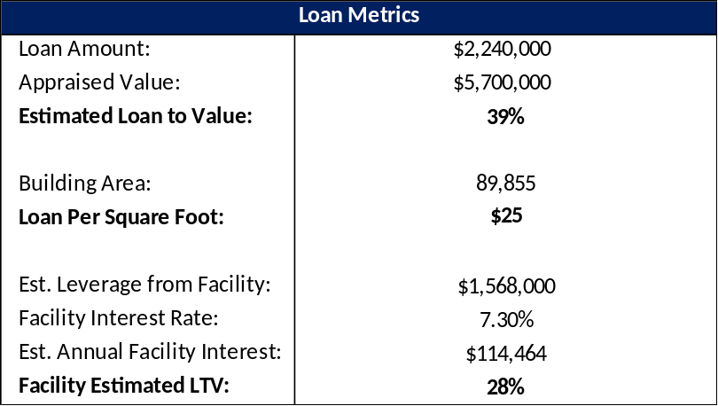
Please see below for an overview of relevant loan metrics and other financial information about the property and transaction:
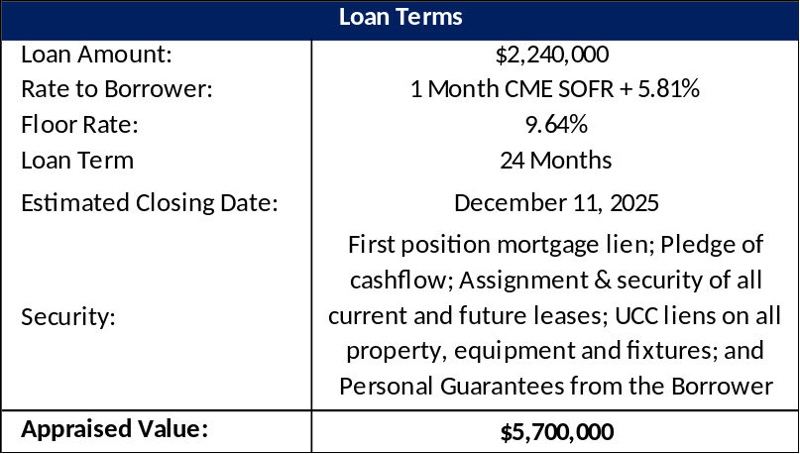

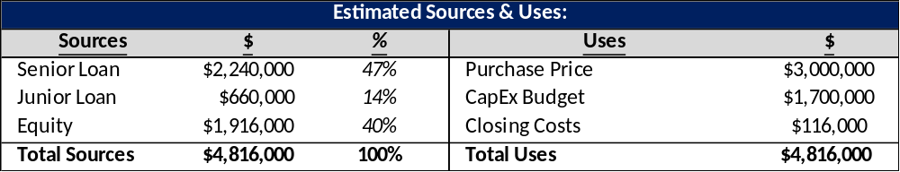
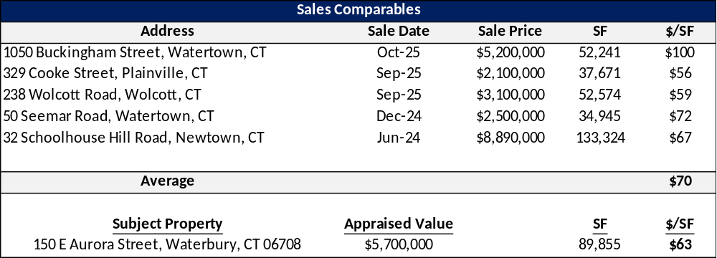

Investment Highlights
Castellan believes this is an attractive investment opportunity for the following reasons:
- This loan presents an attractive risk-adjusted return for a first-lien position in an industrial property in Waterbury, CT.
- Castellan will be providing the loan on the property at a basis of $25/SF, while the sales comps traded at an adjusted average of $70/SF.
- A subordinate loan of $660,000 provided by Reign Funding effectively serves as another layer of security for Castellan.
- Castellans ‘As Is’ LTV is approximately 39%
- In the event the company comes into possession of collateral, Castellan believes that it would have the potential to foreclose on the property and, if successful, take title on an attractive overall cost basis. Unlike traditional lenders, Castellan has the knowledge and infrastructure in place to successfully take ownership and recapitalize the property.

Photo

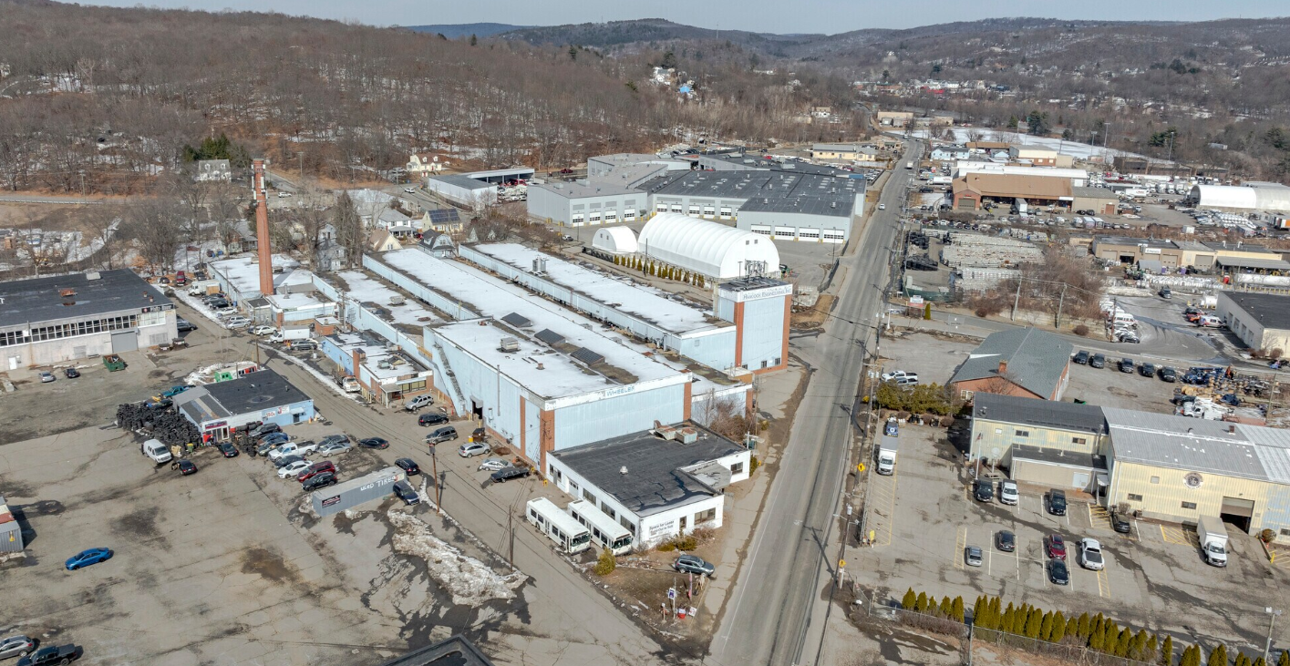
Map
